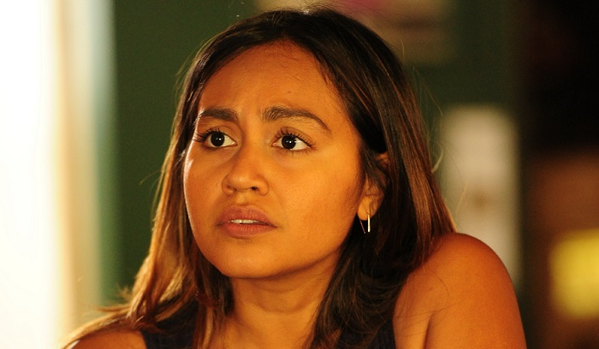

Jessica Mauboy: Becoming The Secret Daughter
By Dov Kornits
September 19, 2016

Popular singer and occasional actress, Jessica Mauboy, faced her biggest challenge yet by taking the lead in the TV series, The Secret Daughter.

“It was probably the most intense experience that I’ve ever been through,” Jessica Mauboy reveals to FilmInk of the preparation for her latest project, The Secret Daughter. “It was like boot camp or military training. I had this responsibility, and this pressure, to take on this lead role. She was this strong young woman…it was the sort of role that I never thought I could play. It took a good two months to really prepare myself, and to give myself to her, and to really let it shine.”
Jessica Mauboy is no stranger to pressure and the spotlight. She strutted across the weekly national stage that was Australian Idol, claiming the runner-up spot (she lost to Irishman, Damien Leith) of the show’s fourth season in 2006. Since then, she’s released three albums, performed at The Eurovision Song Contest, sung in front of Oprah and President Obama, and blasted her way through the national anthem at nearly every sporting event in Australia. She has also appeared in the popular feature films, Bran Nue Dae and The Sapphires, but The Secret Daughter has Mauboy sweating, and with just reason.
The six-part TV mini-series marks her first solo leading role, and the part was written specifically for her. Surrounded by a strong cast that includes local legends, Colin Friels and David Field, Jessica Mauboy plays country girl, Billie Carter, a back-up singer who discovers that she is, yes, the secret daughter of a wealthy magnate, which sends shock-waves through his family.
The challenge of the role – the extended screen time, the amount of character to explore, the challenging emotions – saw Mauboy reaching out to Leah Purcell, a noted actor, writer, director, creator, and chronicler of the indigenous experience.
“She’s wonderful,” Mauboy says of Purcell. “She’s amazingly talented. I was so honoured to be in her presence, and to work closely with her. She was there with me nearly 100% of the way, and still is. She has been encouraging me to discover who I think Billie Carter is, and everything that she should be, and how to present that. That was a huge thing. At the beginning, I found it all very difficult, and Leah broke me in. She really molded me, and taught me not to be afraid. She helped me express the character, and helped me deliver her. I was so happy for Leah’s direction, and for her to give her knowledge to me, and share her stories. That really opened me up to be a part of the show.”
Not unlike Mauboy herself – who was thrust from the relative quiet of Darwin into the noisy national spotlight with Australian Idol – her character of Billie experiences a major disconnect when the truth of her heritage sees her travel from her outback home to the often-way-too-bright lights of the big city.

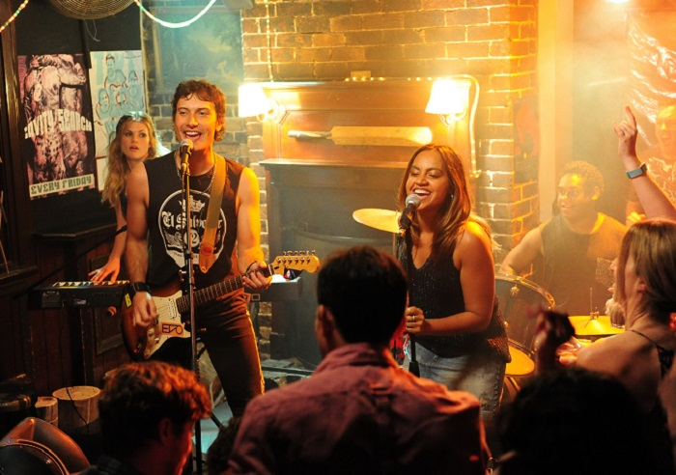
JESSICA MAUBOY IN THE SECRET DAUGHTER
“We get to explore her journey in the outback, through to how she holds up in the city, and how that affects her,” Mauboy explains. “There are a lot of stories out there like that, of people that have grown up in the country, and how they have to juggle life while being away from home, and realising that home is wherever you make it. Every moment in this show feels real to me. I remember struggling with that, and making my home in a different culture, and being in different environments, and trying to deal with them internally. It can be difficult. I thought back to my own upbringing a lot, and I could relate to that. I’d often get emotionally upset, and I’d feel vulnerable, and cry. It just came out so easily. I saw families’ faces, and just instantly cried. Thinking back helped. I’m basing myself in Sydney for work, but I try to get home to Darwin as much as I can. I like to see the family and get a sense of being grounded.”
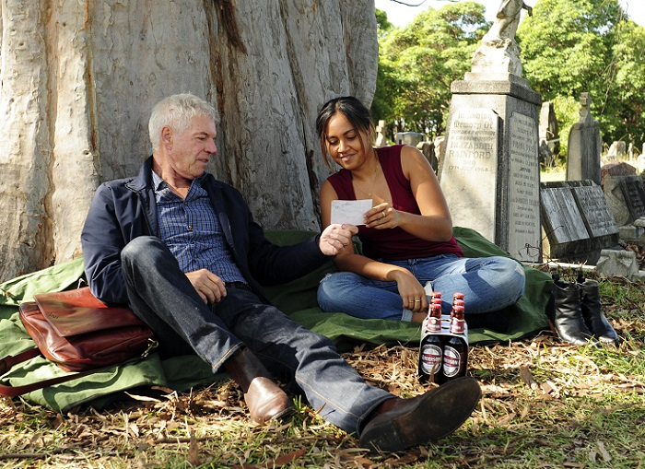
COLIN FRIELS AND JESSICA MAUBOY IN THE SECRET DAUGHTER
To hit all the right notes, Mauboy even opted to stay in character between takes, which made the right kind of impression on one of her co-stars. “I remember David Field looking towards me, and he was like, ‘You know what? Between you and I, out of respect, I thank you so much for being in character. There are not many people that continue to keep in character, and do it over, and over, and over again, until they get it right.’ That was such a massive compliment, and I was just so overwhelmed by David’s respect. I just cried in front of him,” Mauboy laughs.
And though she’d be more than happy to see The Secret Daughter extend beyond its six episodes, Mauboy will always find herself facing the dilemma that most singer/actors experience. “I love my music so much,” she laughs. “When The Secret Daughter came up, I was like, ‘I want to continue to write my next record.’ But I just fell in love with the script. I fell in love with the concept, the story, and how much truth was in there. I loved its message about family, and that no matter where you are, you can make a family, and that can be home as well. It has a very strong message about all those things, and I loved that.”
The Secret Daughter premieres on Channel 7 on October 3.

